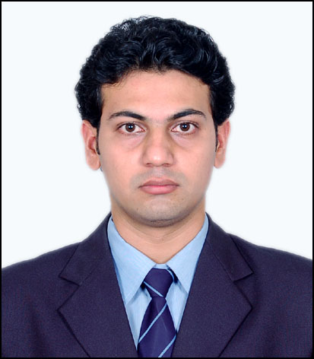

Resume

ADITYA JAYANT KADU

E-mail – adityakadu90@yahoo.in, Mob. (+91) 8805412885, Skype ID: Adityakadu90

Personal Details

Gender: Male Marital Status: Married

D.O.B.: 26th Aug 1986 Language Proficiency: English, Hindi, Marathi.
Permanent Address: 502A-1 Kunal Puram opp.Atlas Copco Ltd Phugawadi, Pune Maharashtra.

Career Objective

To effectively share and enhance my knowledge, skill and experience, and strive continuous for excellence thus benefit self and enterprise.

Experience; Total: 8 years
Bisleri International Pvt Ltd.

- Period: 24.11.2016 – till date.
- Bill booking, Bill booking for Expense, Transport, RM/PM.
- Bank receipt/payment entry.
- Bank reconciliation.
- Accounting System & Gate Entry Process (Navision).
- Ledger to Customer and Vendor.
- Bank related works (D.D, cash withdrawal, deposits).
- Customer Recovery.
- Vendor/Customer Creation.
- Monthly Stock taking.
- IDC Reco
- Customer follow-up for recovery
- Checking Stock and Production reports.
- Credit Note / Debit Note Issue.
- Queries solving queries on call email as and when received.

AXA Business Service

- Period: 26.08. 2015 – 20.11.2016
- Escheatment of Checks.
- Follow up letters.
- Case creation and do follow until ends of case.
- Reissue or reapply of checks.
- Cash and Disbursement report on daily basis.
- Preparing of Northern Trust, Bank of America reports.
- Daily activity of Outgoing wire and Incoming wire.
- (Cash movement) Issue of check on daily basis as and when requested.
- Reversal, stop of checks.
- Monthly reconciliation

Tech Mahindra

- Period: 30.09.2013 – 21.08. 2015
- Role: Process Executive
- Downloading excel reports from various tools/web links, receiving through emails as well.
- Responsible for timely and accurate update of database.
- Reports maintaining SLAs with regards to the client requirements.
- Present the details, reports and analysis statistically to suppliers like GfK and various SPOC’s Analyzing, acquiring & uploading data.
- Wherever applicable Ensure compliance to BT services
- Provide daily, weekly & monthly reports to BT/GfK NOP/SPOCs
- Take & make calls as and when required with BT/ GfK NOP, SPOC’s in UK
- Weekly team conference call as scheduled.
- End user to one Siebel. Uploading new data, or correcting as and when require.

Infosys

- Process Executive, 15.01.2012 to 26.09.2013
- Post incoming payment to customer account
- Post incoming payment to intermediate GL account
- Issuing Invoices as per client request.
- Issuing Sales orders as per client request.
- Issuing Credit Note as per client request.
- Issuing Debit Note as per client request.
- Meeting all the SLA’s as per client requirements.
- Mapping clients’ requirement and coordinating in developing and implementing processes in line with preset guidelines.
- Monitoring the overall functioning of process, identifying improvement areas and implementing adequate measures to maximize customer satisfaction level.
- Reporting for Month End Closing.

Education Qualification
Course | Institute/College/School | University/Board | Percentage | Year of Passing
MBA(Fin) | Aditya Institute Of Management | Pune University | 56% | 2012
Bachelor of Commerce | Dr. D.Y.Patil ACS College Pune | Pune University | 62.3% | 2009
Std XII | Dr. D.Y.Patil ACS College Pune | Pune Board For Secondary And Higher Secondary Education. | 48% | 2006
Std X | Kendriya Vidyalaya | CBSE | 41.8% | 2004

Declaration:

I hereby declare that the above-mentioned information is true to the best of my knowledge.

(Aditya Kadu)

Date:

Place:

